

**Shopping Cart**



**Submitted By**

Muhammad Maaz

Syed Muhammad Sarib

Muhammad Zain

**Professor**

Ms. Aatika Ali

**DEPARTMENT OF COMPUTER SCIENCE**

**AIR UNIVERSITY MULTAN CAMPUS**

**October 2024**

**AUTHOR'S DECLARATION**

It is declared that we have developed a Shopping Cart System. I hereby declare that all my team members are author of this Project.

**Team Leader**

|  |  |
| --- | --- |
| **Student Name** | Muhammad Maaz |
| **Roll No** | 233553 |
| **Discipline** | Computer Science |
| **Year of Study** | 2024 |
| **Area of Study** | C# |
| **Proposed Project Title** | Shopping cart |

**Team Members**

|  |  |
| --- | --- |
| **Student Name** | Muhammad Zain |
| **Roll No** | 233597 |

|  |  |
| --- | --- |
| **Student Name** | Syed Muhammad Sarib |
| **Roll No** | 233505 |

**ACKNOWLEDGMENT**

In the name of ALLAH, The Most Beneficent, The Most Merciful. Alhamdulillah, I am thankful to Allah for granting us the strength to complete this project. We would like to thank our beloved parents. Last but not least, my deepest gratitude goes to my team members who played their role very well.

Thank you very much!

Table of Contents

Chapter No 1: Introduction 6

1.1 Introduction 7

1.2 Tools 7

1.2.1 Hardware 7

1.2.2 Software 7

Chapter No 2: Requirements and Objectives 8

2.1 Requirements 9

2.2 Objectives 9

Chapter No 3: Workflow 11

3.1 Process Flow 12

12

Chapter No 4: Design 13

4.1 UML Diagram 14

Chapter No 5: Implementation 15

# Chapter No 1: Introduction

# 1.1 Introduction

This project involves developing a shopping cart application using Windows Forms, providing a user-friendly graphical interface for managing shopping activities. The primary objectives are to enable users to sign up, log in, browse products, and manage a shopping cart with ease. Key features include adding and removing products, applying discounts, and performing checkout operations. The application is built with C# and leverages an object-oriented design approach. This report covers the system's workflow, class design, and key functionalities, showcasing a functional Windows Forms-based application that captures the core aspects of an e-commerce shopping cart, with potential for further enhancements.

# 1.2 Tools

Some tools are used in developing Shopping Cart.

## 1.2.1 Hardware

* Laptop/PC

## 1.2.2 Software

* Visual Studio
* .NET Framework/SDK 8.0
* Git/GitHub
* Draw.io
* Capcut PC
* Notepad
* Word
* Excel

# Chapter No 2: Requirements and Objectives

# 2.1 Requirements

* Add and remove products from the cart.
* View Cart.
* Item Quantity Management
* Calculate the total cost of items in the cart.
* Apply discounts and sales tax.
* Product Recommendations
* Cart Expiration
* Checkout Process

# 2.2 Objectives

* **Enable Product Management in the Cart**:
  + - Allow users to add and remove products from the shopping cart.
* **Provide Cart Viewing and Management**:
* Display the contents of the cart, including product details and quantities.
* Support item quantity adjustments within the cart.
* **Implement Cost Calculation**:
* Calculate the total cost of items in the cart, factoring in individual prices and quantities.
* **Apply Discounts and Sales Tax**:
* features to apply discounts and calculate sales tax for the final total.
* **Integrate Product Recommendations**:
* Suggest products to users based on their cart contents.
* **Streamline the Checkout Process**:
* Facilitate a straightforward checkout process for completing purchases.
* **Use Collections for Data Management**:
* Utilize List<Product> for managing the collection of products within the cart.

# Chapter No 3: Workflow

# 3.1 Process Flow

# 

# Chapter No 4: Design

## UML Diagram

# Chapter No 5: Implementation

## 5.1 SignUp

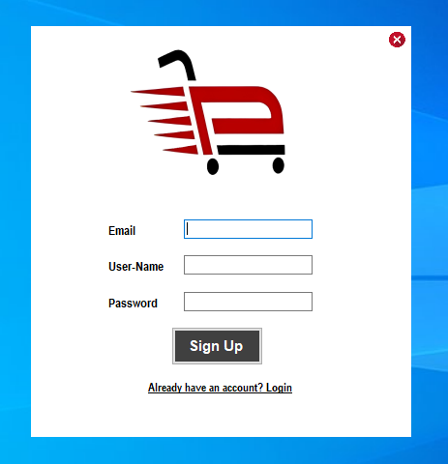

## 5.2 Login

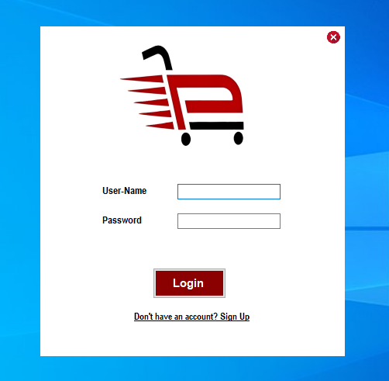

## 5.3 DashBoard

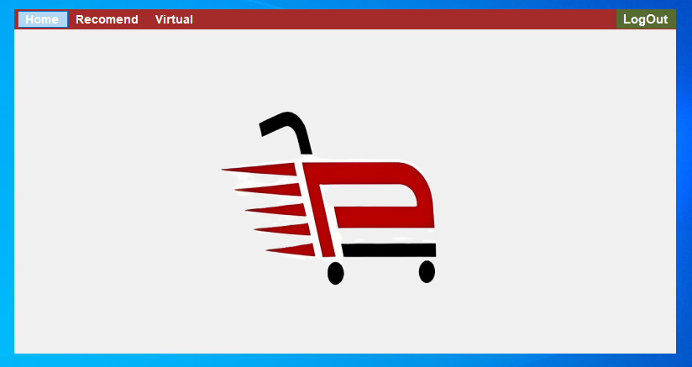

## 5.4 Recommend

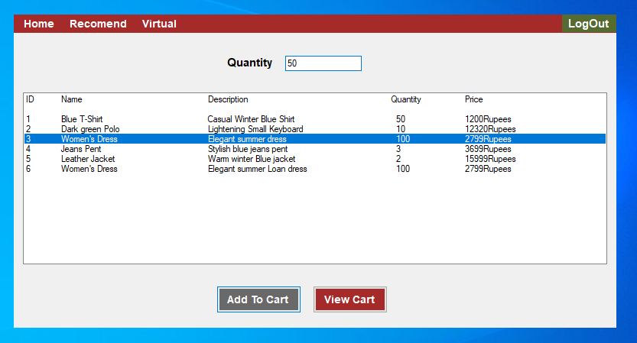

## 5.5 Virtual

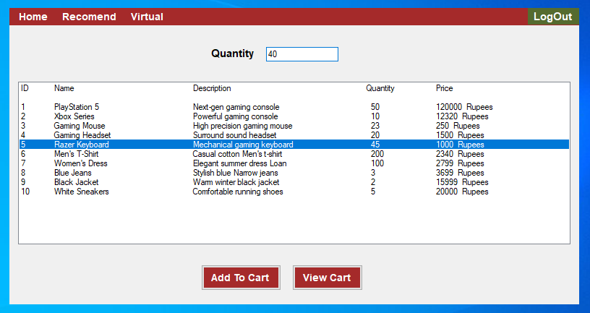

## 5.6 Cart

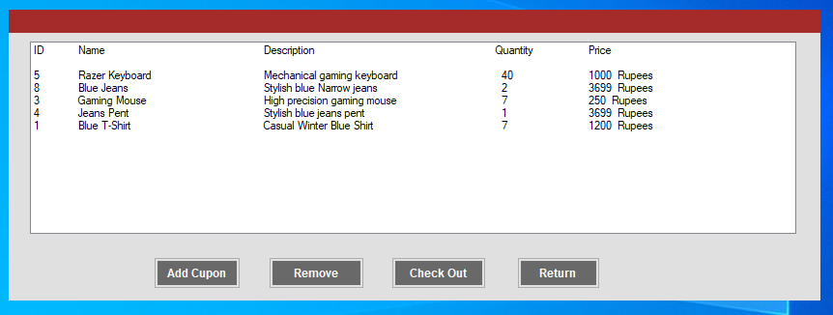

## 5.7 Coupon

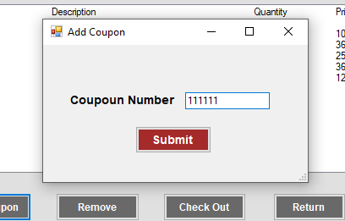

## 5.8 Bill

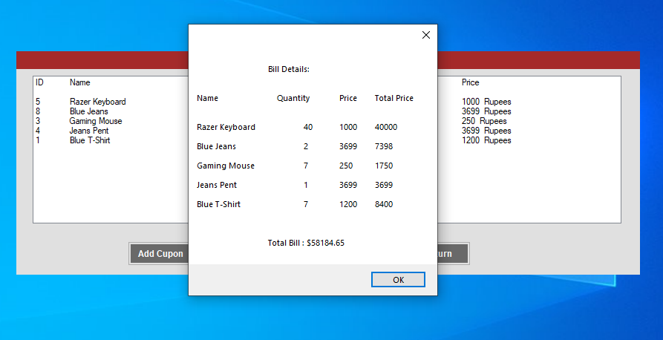

Github: https://github.com/Muhammad-Maaz-0990/Shopping_Cart

Video: https://youtu.be/eDuf8vcZEyc?si=hpeyaWZulf1OOBpF

**I hope that this report will conclude all requirements and describe my project very Well.**